**American International University-Bangladesh (AIUB)**

**Department of Computer Engineering**

COE 3201: Data Communication Laboratory

**Lab Report 5**

**Title: Study of Digital to Analog Conversion using MATLAB**

**Supervised By**

**Sadman Shahriar Alam**

## Submitted By

|  |  |
| --- | --- |
| **Name** | **ID** |
| **SHAYAN ABRAR** | **22-47156-1** |

## Group Members

|  |  |
| --- | --- |
| **Name** | **ID** |
| **MD. JOBAER HOSSAIN** | **22-47116-1** |
| **MD. SAMIN YEASAR** | **22-47139-1** |
| **RIFAH SANZIDA** | **22-47154-1** |

**MATLAB Code:**

1.

close all;

clc;

f=5;

f2=10;

x=[1 1 0 0 1 0 1 0]; % input signal

nx=size(x,2);

i=1;

while i<nx+1

t = i:0.001:i+1;

if x(i)==1

ask=sin(2*pi*f*t);

fsk=sin(2*pi*f2*t);

psk=sin(2*pi*f*t);

else

ask=0;

fsk=sin(2*pi*f*t);

psk=sin(2*pi*f*t+pi);

end

subplot(3,1,1);

plot(t,ask);

hold on;

grid on;

axis([1 10 -1 1]);

title('Amplitude Shift Key')

subplot(3,1,2);

plot(t,fsk);

hold on;

grid on;

axis([1 10 -1 1]);

title('Frequency Shift Key')

subplot(3,1,3);

plot(t,psk);

hold on;

grid on;

axis([1 10 -1 1]);

title('Phase Shift Key')

i=i+1;

end

**Results:**

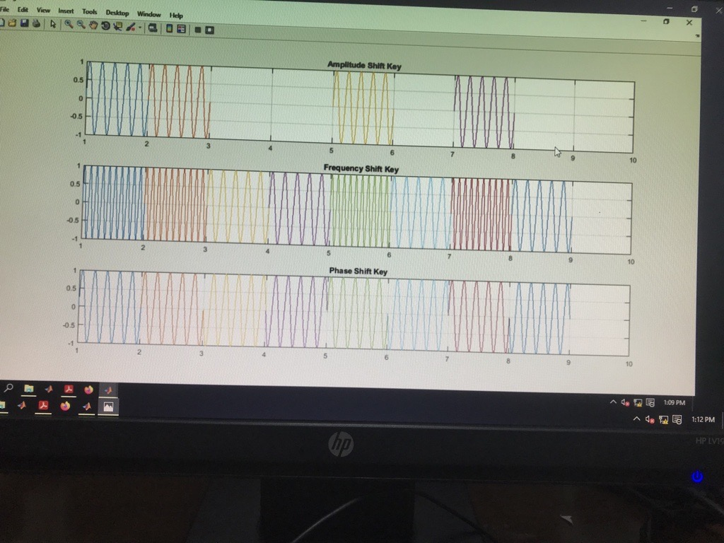

**Figure: digital to analog modulation (Ask, FSK and PSK)**